OCEAN FLOOR MAPPING—LAB ACTIVITY

Ocean Floor Mapping

(Activity #25)

Purpose Create a profile map of a contrived (artificially designed) “ocean floor”
and relate the process to ocean floor mapping.

Background Through the use of various technologies, scientists have been able to create profiles of the oceans’ floors. Sonar technology is often used to gather data about the ocean basin. Ships that are used to map the sea floor do so by sending a signal, or energy wave, from a ship’s bottom to the ocean floor. A receiver on the ship records the amount of time it takes for the signal to be reflected and travel back to the ship. With knowledge about the velocity of the energy waves the distance to the bottom is calculated and plotted. The process is repeated for many locations until the shape of the structures becomes evident.

How did people tell what the land under water was shaped like before there was sonar technology?

Famous American author Samuel Langhorne Clemens’ choice of pseudonym, Mark Twain, was inspired by his experience as a Mississippi River steamboat pilot. The Mississippi River is a notoriously muddy one, and it is generally impossible to assess its depth with the naked eye. The river depth varies, necessitating a method for measuring the distance from the boat bottom to the river bed. For safe navigation, steamboats required a distance of at least twelve feet from the bottom of the boat to the riverbed. To ensure this depth, a crew member would drop a line into the river. If the water passed the two-fathom (twelve foot) mark on the line, the crew member would yell “by the mark, twain!” Not only did this rudimentary technology provide Samuel Clemens with his nom de plume, it formed the early basis for mapping ocean basin topography.

For the better part of human history, sea floor topography has been of little interest. Although the ocean basin makes up 70% of the Earth’s crust, little was understood about it prior to the nineteenth century. Most people believed the sea floor to be relatively featureless. What little was known of the ocean floor was the result of leadline measurements, similar to those made by Mark Twain's ilk. A lead- weighted line was dropped from the side of a boat. When the line struck a surface, researchers would note the distance from the ocean surface to the end of the line. A series of measurements was conducted over a small area, which, once aggregated, provided a simple picture of a small area of the ocean basin. A portion of a large ocean ridge known as the global mid-ocean ridge was discovered using this method.

EXPLORATIONS IN EARTH & ENVIRONMENTAL SCIENCES 375
OCEAN FLOOR MAPPING—LAB ACTIVITY

Background,
continued

The discovery of the mid-ocean ridge led to the subsequent development of plate tectonics theory. Mid-ocean ridges are sites of sea floor spreading, areas at which new oceanic lithosphere (outer part of the solid earth composed of rock) is constantly being created. This phenomenon was documented through the use of magnetometers to study the magnetic characteristics of the ocean floor. In the 1950s, scientists discovered a characteristic of the ocean floor known as magnetic striping.
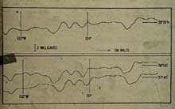
Early magnetic profiles from Pioneer (a ship that towed the first marine magnetometer) surveys. The top profile, as compared to the bottom two, shows the repeating magnetic “striping” pattern that occurs after crossing over the Mendocino Fracture Zone. (NOAA Photo Library).

Magnetic striping occurs at regular intervals along the ocean basin, as a result of magma rising through the ocean ridge as it is pushed up by convection currents in the mantle. Magma cools, forming basalt, which contains a magnetic mineral called magnetite. Magnetite crystals in the basalt orient themselves according to the Earth’s magnetic field. Scientific measurements revealed magnetic stripes along the ocean floor. At regular intervals, the magnetic field of the sea floor reverses, indicating polar reversals of the Earth’s magnetic field. On either side of the ocean ridge, the stripes are present. In addition, the pattern is identical on both sides of the ridge, indicating that the sea floor is moving outward from the ridges.

What did these early technologies reveal about the sea floor? Magnetic striping demonstrated that the Earth’s crust was constantly being created. However, the size of the Earth’s crust remains relatively stable. If new crust is being created at the ridges then it must be destroyed somewhere else.

The mid-ocean ridges have their counterpart in ocean trenches. The sea floor is spreading at the ridges, and it is subducted at the trenches. Generally, trenches lie near continental crust. At these points, ocean floor moves underneath the continental crust. These areas also have much more active geological behaviors, such as earthquakes and

376 EXPLORATIONS IN EARTH & ENVIRONMENTAL SCIENCES

OCEAN FLOOR MAPPING—LAB ACTIVITY

Background,
continued

volcanoes. In fact, the majority of the Earth’s volcanoes are located in the “Ring of Fire,” along the edges of the Pacific Ocean Basin.

Plate tectonic theory provides the widely accepted explanation for the co-occurrence of volcanoes, earthquakes, and trenches. Tectonic plates are large sections of the Earth’s crust that move about on the mantle beneath. As previously stated, the sea floor is subducted beneath continental crust in the trenches. These regions are highly active, as a result of the convergence plate boundaries. Convection currents in the mantle cause the spreading and subduction to occur. Sea floor spreading creates ocean ridges, which are like the mountain ranges on land. Subduction gives rise to ocean trenches, earthquakes and volcanoes. Other seafloor structures such as seamounts and guyots form as the result of the movement of tectonic plates. A seamount is the marine equivalent of a mountain, and a guyot is an island that has been either eroded or moved by sea floor spreading so that it no longer extends above the surface of the ocean.

How has sonography contributed to the knowledge of the structure of the sea floor?

Through the use of various technologies scientists have been able to create topographic maps of the oceans’ floors. Ocean floor mapping technology has become more sophisticated in recent years. Sonar technology is often used to gather data about the ocean basin. Ships that are used to map the sea floor do so by sending a signal, or energy wave, from a ship’s bottom to the ocean floor. A receiver on the ship records the amount of time it takes for the signal to be reflected and travel back to the ship. With knowledge about the velocity of the energy waves the distance to the bottom is calculated and plotted. The process is repeated for many locations until the shape of the structures becomes evident.

Research has provided evidence that the structures on the sea floors are much larger in magnitude than the corresponding structures on the continents. For instance, Mt. Everest would not even come close to being as tall as the Mariana Trench is deep. Not surprisingly, there is less research about the abyssal plains (great flat sediment-covered areas of the deep ocean floor), which cover more than half of the ocean floor, than about the continental shelves (comparatively shallow submarine plains of varying widths from several to several hundred miles forming borders to continents and typically ending in continental slopes down to abyssal plains). This reduced amount of research on abyssal plains is because the ocean depth over abyssal plains is very great, causing such high pressure and such low temperatures that studying is extremely difficult. As technologies continue to improve, scientists will gradually gain greater understanding of the ocean basins.

EXPLORATIONS IN EARTH & ENVIRONMENTAL SCIENCES 377

OCEAN FLOOR MAPPING—LAB ACTIVITY

Background,
continued

How does the Motion Sensor can simulate this sonar technology? The Motion Sensor used in this activity works the same way as sonar. Sound waves are sent out from the sensor, reflect from an object, and are received back by the sensor. The computer calculates the distance the sound waves traveled and plots the distance on the graph. As a result, shorter distances are plotted lower on the y axis (which is the distance axis) while larger distances are plotted higher on the y axis. This causes the graph to appear “upside down” compared with the objects’ heights from the floor, since the taller objects are actually closer to the Motion Sensor.

Bathymetry is the science of measuring ocean depths to determine the topography of the sea floor. In this exploration, you will be making simulated bathymetric measurements to map the contour of an “ocean floor” that you create.

Materials and
Equipment

• Xplorer GLX • objects of varying heights

Required
• PASPORT Motion Sensor
(stacks of books, etc.)

Safety Notes Remember, follow the directions for using the equipment.

Pre-Lab
Questions

1. How do you think the graphed data will look? Draw a sketch of what you think it will look like.

Procedure GLX Setup
1. Plug the PASPORT Motion Sensor into the Xplorer GLX.

2. Use the arrow keys (  ) to highlight the Flash folder, select the Flash folder (press  ), use the arrow keys to highlight the file, and then open (press F1) the GLX configuration file entitled

25 Ocean Floor Mapping CF

3. Open the Graph display (press  , F1).

378 EXPLORATIONS IN EARTH & ENVIRONMENTAL SCIENCES

OCEAN FLOOR MAPPING—LAB ACTIVITY

Procedure,
continued

Equipment Setup

1. Arrange the objects on the floor to simulate ocean floor features. Include any combination of “seamounts, ocean ridges, trenches, abyssal plains” or other sea floor structures.

2. Rotate the gold disk on the Motion Sensor so it points to the floor. Select the ‘cart’ icon on the top of the Motion Sensor.

3. Hold the Motion Sensor at arm’s length over at the beginning of the “ocean floor”.

Record Data

1. Press the Start/Stop ( ) key to begin data recording.

2. Immediately after pressing the Start/Stop key, you must begin walking slowly, but at constant velocity, with the Motion Sensor over the “ocean floor”.

3. Press the Start/Stop key to stop data recording immediately when you reach the opposite end of the “ocean floor”. That is, data recording should occur only when the Motion Sensor is over the “ocean floor”.

Note: This could take some practice. Do not be afraid to stop collection early and try again.

To delete unusable data, do the following:
1. Press the select key and use the arrow keys to navigate to the Run # field.
2. Press the select key, use the arrow keys to navigate to
Delete Run...), press the select key, and press F1 (OK).

4. Make a sketch of your graph on a data sheet such as the one shown on the following page.

5. Save your GLX file (press , select Data Files, press F2).
Result: Your GLX file will be saved in the RAM folder.

Note: Your teacher may ask you to rename your file so you can find it later. If so, use the following procedure:
1. Select the Files menu (press F4) and select Rename.
2. Key in the new name, and press the Save key (F2).

6. Follow your teacher’s instructions regarding cleaning up your work space and putting away the equipment.

EXPLORATIONS IN EARTH & ENVIRONMENTAL SCIENCES 379

OCEAN FLOOR MAPPING—LAB ACTIVITY

Example Data
Table

Analysis/ Synthesis Questions

Sketch of the GLX graph data of height as determined by the Motion
Sensor versus Time (a way of measuring location).

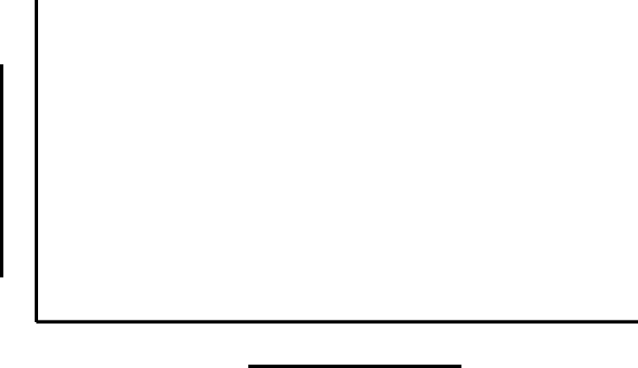

Analysis questions

1. How does this graph compare to your prediction?

2. Describe any differences between the profile on the floor and the graph on the screen.

3. Explain why you think there may be differences.

4. What would you need to do to make this graph appear to be like a typical profile?

Synthesis questions

1. What Earth process causes the formation of a mid-ocean ridge?

2. What Earth process creates a seamount or island like Hawaii?

3. How does the size of the Earth’s surface features (mountains and canyons) compare with the size of Earth’s ocean floor features (seamounts and trenches)?

4. Why do we know so little about life on the abyssal plains?

5. Describe how sonar or radar is used by scientists to map the floor of the Earth’s oceans.

6. To make your results more accurate, what could be graphed on the x axis instead of time (if you had proper equipment)?

380 EXPLORATIONS IN EARTH & ENVIRONMENTAL SCIENCES

