WATER TREATMENT—LAB ACTIVITY

Water Treatment

(Activity #7)

Purpose Can you build a filter device that improves water quality?

Background Water is a limited resource
There are several steps in the water treatment process that are common to both drinking water and wastewater treatment. Among these similar processes are coagulation, flocculation, and filtration. Filtration technology is abundant, and can be used to remove nearly any impurities from water. However, using solely filtration devices is not cost-effective, and usually filtration is combined with a complement of other water treatment methods.

In water treatment, water is usually passed through a series of filters with different-sized pores to ensure effective cleansing. These filters are composed of various media, or granular material of varying size. Filtration works by trapping impurities in the spaces between the granules of the media and allowing the water to flow through it. The size of the pores determines which impurities the filter media remove from the water.

Some filters work not only through the physical means of trapping particles, but chemically as well. One chemical process is adsorption, in which impurities stick to the filter medium as a result of intermolecular attractions between the filter granules and the particles or chemicals in the water. This is how most home water filtration systems work.

Diagram of a municipal water treatment system

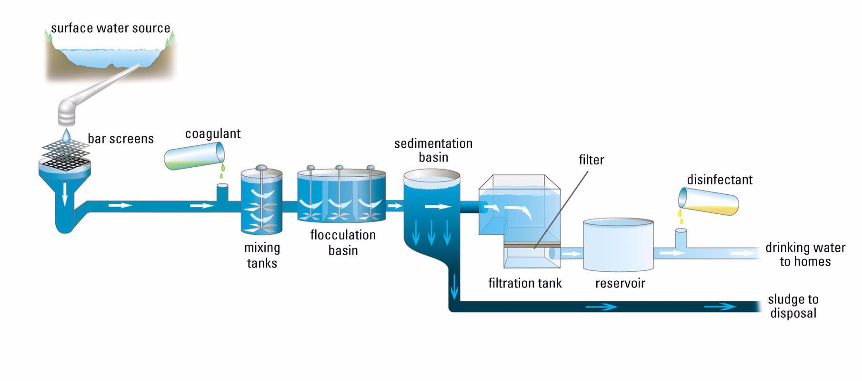

EXPLORATIONS IN EARTH & ENVIRONMENTAL SCIENCES 97
WATER TREATMENT—LAB ACTIVITY

Background,
continued

Water treatment improves water quality

There are several general steps to water treatment, regardless of the type of water being treated (drinking water or wastewater).

• Large solids removal;

• Coagulation;

• Flocculation;

• Sedimentation;

• Filtration; and

• Disinfection

In drinking-water treatment, water is usually removed from a surface water source such as a river or lake and processed by a drinking-water treatment facility. Wastewater flows to wastewater treatment plants through the sewer system. In both cases, water undergoes a series of processes intended to clarify it to an acceptable level—for use in the home in the case of drinking water, and to send back into the environment by wastewater treatment plants in the case of wastewater.

Large solids removal

First, large solids are removed from the water by passing it through a large grate. Large objects such as rocks and tree branches are trapped by the screen while the water and smaller debris move further into the treatment process.

Coagulation, flocculation, and sedimentation

Removing large solids is simple compared with the procedures needed to rid water of dissolved and suspended solids. Larger solids will settle out of the water given time and the force of gravity. Dissolved and suspended solids, on the other hand, are less tractable. Dissolved solids are defined as solids in water that cannot be trapped by a filter. Since these solids are often dissolved salts, they can contribute to a change in the conductivity of water. This enables use of the electrical conductivity of water to approximate the total dissolved solids in water. As a general rule of thumb, total dissolved solids (TDS), are related to conductivity in the following manner:

Some solids are not dissolved in water, but can still affect water’s clarity and conductivity. Waters with high levels of suspended solids are usually cloudy, or turbid. Highly turbid waters are detrimental to the environment, causing decreased light penetration resulting in a cascade of negative changes to an aquatic ecosystem.

98 EXPLORATIONS IN EARTH & ENVIRONMENTAL SCIENCES

WATER TREATMENT—LAB ACTIVITY

Background,
continued

The interrelated processes of coagulation, flocculation, and sedimentation are used to remove suspended and dissolved solids from water. First, a coagulant is added to the water. This causes suspended particles to form clumps. Next, these clumps aggregate into larger clumps, or flocs, through the flocculation process. These flocs usually float to the top or become dense enough to settle out of the water. This is a solid-liquid separation process known as sedimentation.

Filtration

After removing the majority of the floc, the water must be filtered, since it still contains some floc, silt, bacteria, and other debris. Specifically, filtration is a process that removes impurities from water by percolating it downward through a layer of porous, granular material. Water can be forced through the filter in a variety of ways, including gravity, centrifugal force, pressure, and/or a vacuum. Suspended particles become trapped within the pore spaces of the filter media and the water passes through the filter. The size of the pores in the filtering material is important; pores can only trap particles that are larger in size than the pore—larger pores trap larger materials and smaller pores can trap smaller particles. Water filtration frequently involves passing the water through a series of different sizes of filtering materials to capture particles of differing sizes; this is known as mixed-media filtration. Filters for suspended particle removal can be made of graded sand, gravel, clay, granular synthetic material, charcoal, screens made from various materials, and fabrics. In municipal wastewater treatment, the filter medium may be pre-coated with a filtration aid such as ground cellulose. There are several different types of filters, each used for specific applications.

In addition to the pores acting as traps for the materials in the water, some of the impurities will stick to the filter media itself. This is known as adsorption. Adsorption is a chemical
phenomenon. Activated carbon (also known as activated charcoal) filters draw impurities from the water through adsorption. Many households in the United States feel the need to filter their water further after it is delivered to the home. Often, home filtration systems are used. Activated carbon filtration (carbon adsorption) is the most widely sold method for home water treatment because of its ability to improve water by removing disagreeable tastes and odors.

Disinfection

Finally, water is disinfected. Disinfection involves the addition of chemicals to water to kill water-borne pathogens that are not destroyed in other parts of the water treatment process. At this point, water is safe for release into the home or environment.

EXPLORATIONS IN EARTH & ENVIRONMENTAL SCIENCES 99

WATER TREATMENT—LAB ACTIVITY

Materials and Equipment Required

• Xplorer GLX • cheesecloth, 15 x 15 cm
• PASPORT pH Sensor • wastewater sample (500 mL)

• PASPORT Turbidity Sensor • circular screen, 5-cm diameter

• PASPORT Water Quality Sensor with
Conductivity Probe • pipet
• beaker, 150-mL • plastic soda bottle, 0.5-L

• sand (50 g) • scissors

• gravel (50 g) • paper towels
• activated charcoal (50 g) • lab coats

Safety Notes Remember, follow the directions for using the equipment.

Pre-Lab
Questions

1. How do you think sand, gravel, and charcoal filter media will affect water quality measurements, namely pH, conductivity and turbidity? Why do you think this?

Procedure
(Part A)

PART A—Testing different filtration methods

Equipment setup

1. Cut the bottom off the soda bottle. You will use the top as a funnel and the bottom to collect the water to pour through your filter.

2. Wrap the screen in cheesecloth. Place the screen in the bottom of the funnel.

3. Place the funnel in the
150-mL beaker.

4. Put about 25 g of sand into the funnel.

5. Pour about 100 mL of the tap water into your sand filter system. After

that filters through, pour about 100 mL of deionized or distilled water into your filter system.
Note: The purpose of this step is to compact the filter medium down onto the screen-cheesecloth assembly and pre-wash the filter.

100 EXPLORATIONS IN EARTH & ENVIRONMENTAL SCIENCES

WATER TREATMENT—LAB ACTIVITY

Procedure
(Part A),
continued

GLX Setup

1. Plug the PASPORT Water Quality and Turbidity Sensors to the Xplorer GLX. Connect the pH Probe and the Conductivity Probe to the Water Quality Sensor.

2. Use the arrow keys (  ) to highlight the Flash folder, select the Flash folder (press  ), use the arrow keys to highlight the file, and then open (press F1) the GLX configuration file entitled

07 Water Treatment CF

3. Open the Table display (press  , F2).

4. Press the flask icon (middle sensitivity) on the Water Quality
Sensor.

Record Data—Part A (test 3 different types of filtration media)

Testing the unfiltered “wastewater”

1. Immerse the ends of the pH and Conductivity Probes in the unfiltered “wastewater”.
Note: Be sure that the holes near the end of the Conductivity
Probe are immersed.

2. Use your pipet to get an aliquot of the unfiltered “wastewater” from the middle of the sample and put it in the cuvette of the Turbidity Sensor. Put the lid on the cuvette.
Note: Be sure to wipe the cuvette surface with a towel or tissue to remove any fingerprints.

3. Tip the cuvette upside down 2 or 3 times to mix the contents. Place the cuvette in the Turbidity Sensor and close the lid.

4. Press the Start/Stop key (  ) to begin data recording.

5. When the measurements begin to stabilize, press the Start/ Stop key to stop recording data.
Note: Even when the measurements have stabilized, they may continue to fluctuate slightly, which is OK and will not adversely affect the quality of your results.

6. Record the last measurements on the Table display in a data table such as the one shown on page 104.
Note: Be sure to note the appearance and smell of the filtrate
(filtered “wastewater”) on your data table.

EXPLORATIONS IN EARTH & ENVIRONMENTAL SCIENCES 101

WATER TREATMENT—LAB ACTIVITY

Procedure
(Part A),
continued

7. Rename your data run as follows:
1. Press the select key, use the up-arrow key to navigate to the Run label, and select it.
3. On the Run menu, use the down-arrow key to navigate to Rename Run, and select it. Key in an appropriate name, such as unfiltered and press the OK key (F1).

Testing the filtrate (filtered “wastewater”) from the sand filter system

8. Pour about 100 mL of the “wastewater” into your sand filter system.

9. Repeat steps 1 through 7 for the filtrate from your sand filter system.

10. Discard the contents of the funnel into a waste receptacle, but be sure to retrieve the screen and cheesecloth.

11. Rinse the probes, cuvette, screen, cheesecloth, pipet, beaker, and funnel in tap water. Place the funnel in a beaker.

Testing the filtrate from the gravel filter system

12. Wrap the screen with the cheesecloth and put it in the bottom of the funnel. Then, put about 25 g of gravel into the funnel. This is your gravel filter system.

13. Pour about 100 mL of the tap water into your filter system. After that filters through, pour about 100 mL of deionized or distilled water into your filter system. Discard this filtrate.

14. Pour about 100 mL of the unfiltered “wastewater” into your gravel filter system.

15. Repeat steps 1 through 7 for the filtrate from your gravel filter system.

16. Discard the contents of the funnel into a waste receptacle, but be sure to retrieve the screen and cheesecloth.

17. Rinse the probes, cuvette, screen, cheesecloth, pipet, beaker, and funnel in tap water. Place the funnel in a beaker.

Testing the filtrate from the activated charcoal filter system.

18. Repeat steps 12 through 17 for the activated charcoal filter system.

102 EXPLORATIONS IN EARTH & ENVIRONMENTAL SCIENCES

WATER TREATMENT—LAB ACTIVITY

Procedure
(Part A),
continued

19. Save your GLX file (press , select Data Files, press F2).
Result: Your GLX file will be saved in the RAM folder.

Note: Your teacher may ask you to rename your file so you can find it later. If so, use the following procedure:
1. Select the Files menu (press F4) and select Rename.
2. Key in the new name, and press the Save key (F2).

Procedure
(Part B)

PART B (design and test your own filtration system)

Equipment Setup

1. Using your experience with filtration media and and filtration performance that you gained from Part A, design a filter through which you can drain your wastewater.

2. Fill the funnel with about 25 g of each media, in the order you choose.
Note: You may choose to use media in more than 1 layer.

3. Rinse the filter system with about 100 mL of tap water, followed by about 100 mL of
deionized or distilled water. Dump the water into your wastewater container or down the drain.

4. Pour about 100 mL of the “wastewater” into your designed filter system.

5. Repeat steps 1 through 7 of Part A for the filtrate from your designed filter system.

6. Save your GLX file using the procedure detailed in Part A.

EXPLORATIONS IN EARTH & ENVIRONMENTAL SCIENCES 103

WATER TREATMENT—LAB ACTIVITY

Example Data Table for Parts A and B

Water Quality Measurements

pH Conductivity
(∝S/cm)

Turbidity
(NTU)

Smell Appearance

PART A
Unfiltered Sand Gravel Charcoal PART B

My filtration system

Analysis/ Synthesis Questions

Analysis questions—PART A

Answer the following questions before you go on to PART B.

1. Which medium had the greatest effect on the pH of your sample?

2. Which medium had the greatest effect on the conductivity of your sample?

3. Which medium had the greatest effect on the turbidity of your sample.

Analysis questions—PART B

1. Draw a diagram of your filter system. Label each part.

2. Compare the results you got with your custom-designed filtration system with those you got with the individual filter media. Be sure to make comparisons regarding the rate of filtration. Why might this be important?

104 EXPLORATIONS IN EARTH & ENVIRONMENTAL SCIENCES

WATER TREATMENT—LAB ACTIVITY

Analysis/ Synthesis Questions, continued

Synthesis questions

1. Refer to your data table for Part A. Can you explain the effect each medium had on your water quality measurements?

2. Why did you organize the layers in the filter device the way you did?

3. How might you modify your filtration system to improve its performance?

4. Did any of the media work through adsorption? If so, what evidence do you have of this?

5. Classify the media as chemical or physical agents. Explain your rationale.

6. From the results obtained by other groups in your class, does there seem to be a filter design that works better than others?

EXPLORATIONS IN EARTH & ENVIRONMENTAL SCIENCES 105

WATER TREATMENT—LAB ACTIVITY

106 EXPLORATIONS IN EARTH & ENVIRONMENTAL SCIENCES

