
I Scream You Scream- We All Scream for Ice Cream!

Purpose:
- What phase changes occur while making ice cream?
- What happens to the freezing point of ice when you add salt to water?

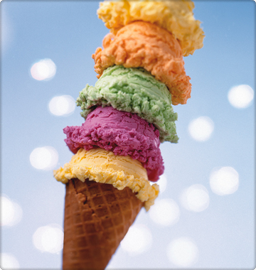
Precautions: The most hazardous substance in this lab is the rock salt. If there are leaks in the inner bag, salt may contaminate the ice cream- YUCK! Caution should be exercised in opening the inner bag after the ice cream is frozen so that none of the salt water enters. The salt is necessary to lower the freezing point of ice to make water at a temperature colder than zero degrees.

Materials:
- ½ cup of milk
- ¼ teaspoon vanilla
- 1 tablespoon sugar
- 2 Ziploc freezer bags (1 gallon size and 1 quart size)
- 2 cups ice
- 1-2 tablespoons rock salt
- Plastic spoons
- Bowls
- Measuring devices
- Ice cream toppings

Procedure: Place vanilla, milk and sugar in the smaller Ziploc bag and seal securely. Place the ice and rock salt in the larger Ziploc bag along with the sealed smaller bag. Seal the larger bag and shake or rock the bags by holding the corners of the bag. It may take 10-15 minutes for your ice cream to “harden”. The consistency will be like cold mashed potatoes. Once hard carefully transfer your ice cream to a bowl- do not allow the bag to drip into the bowl- and add toppings. ENJOY!
After eating your ice cream take the temperature of your ice-water bag and record below. Clean up!

Normal Freezing Point of Water | Temperature of Ice-Water Mixture

Conclusion:

- Describe all phase changes that occurred during the lab. Be specific- when did the change occur? Draw a picture to aid in your discussion.
- Identify each change as either exothermic or endothermic.
- Why is the salt added to the ice?

