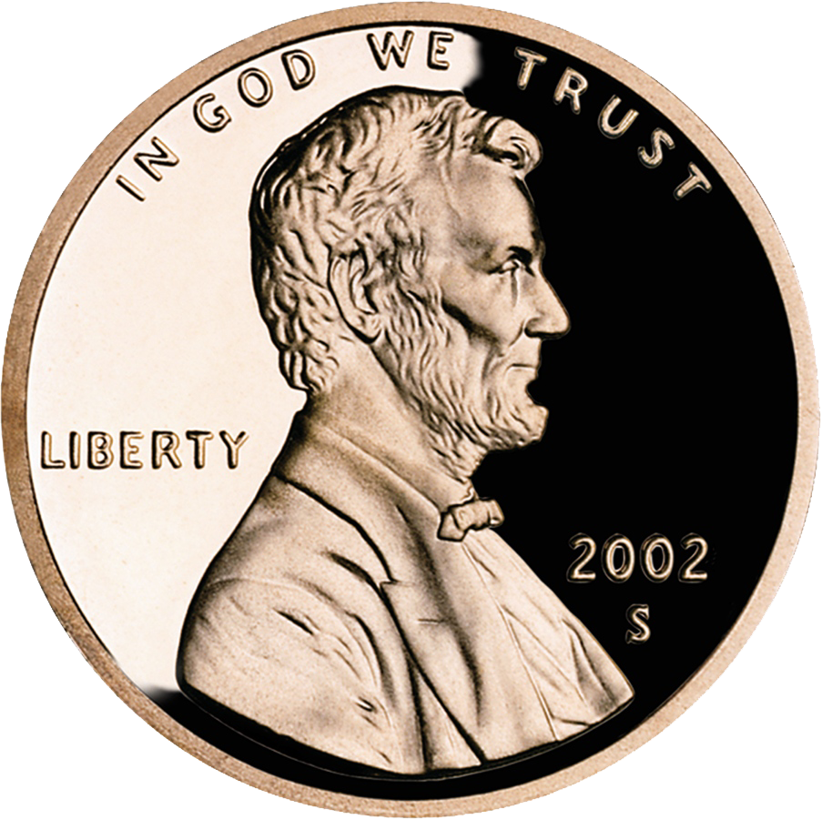
Are all Pennies Created Equal?

Purpose: In this lab you will determine if there is a difference in the percent copper of “old” pennies (pre-1982) and “new” pennies (post 1982).

Background: Single replacement reactions involve the reaction of an element with a compound to produce a new element and a new compound:
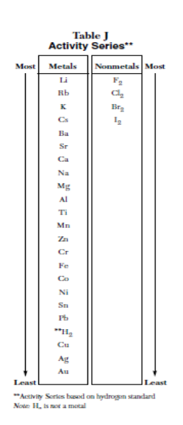
A + BC → AC + B

Single replacement reactions will not always occur. In a metal displacement, the metal that is being displaced must be less reactive than the metal that is doing the displacing.
The same rules apply for nonmetal displacement.

An activity series (Table J) can be used to predict whether or not a single displacement reaction will occur. The activity series of metals (or nonmetals) is a list of metals, typically arranged by decreasing relative reactivity.

Metals of greater reactivity are arranged higher on the list than metals of lesser reactivity. If the metal that is doing the displacing is located higher on the activity series than the metal that is being displaced, then the reaction will occur. If not, then no reaction will take place.
In this lab you will take advantage of the different reactivity’s of the metals used to make pennies: copper and zinc.

Hypothesis:
- Use the information presented in the background and in table J to determine what single replacement reaction will occur when HCl (hydrochloric acid) is mixed with the zinc and copper of the pennies. Will copper react with HCl to displace the H₂? Will zinc react with HCl to replace the H₂? Explain what you think will happen and write a reaction to illustrate this.

- Do you think there will be a difference in the amount of copper and zinc in the old and new pennies? Why or why not?

Procedure:

DAY I
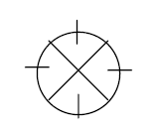
1. Take a post-1982 penny and, using a triangular file, etch an “X” on one side of the penny. Also etch a notch on the edge of the penny in the four positions shown in the diagram.
2. Mass and record the mass of the penny.
3. Using a graduated cylinder, measure 60.0 mL of 3.0 M HCl and pour it into your beaker.
4. Place the penny in the HCl solution etch side up and record observations for 3-5 minutes.
5. Label your beaker with your name and type of penny.
6. Repeat with a pre-1982 penny.

Day 2

1. Using your forceps, carefully remove what is left from the penny. Rinse it gently in distilled water.
2. Dry the penny in acetone solution. Swirl the penny in the solution.
3. Pour the acid solution from your beaker down the drain. Rinse and dry your beaker.
4. Place the penny in the beaker and allow the penny to dry over the weekend. Repeat with other penny.

DAY 3
1. Mass and record the mass of the penny that remains. Repeat with the other penny.
2. Complete the questions and calculations.

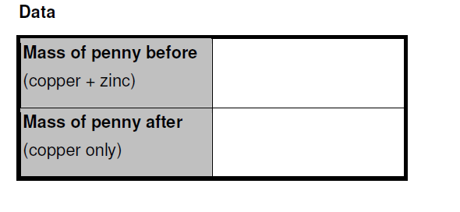
Calculations and Questions:
1) Write a balanced reaction for the reaction of zinc with hydrochloric acid.
2) Explain why the zinc reacted with the hydrochloric acid but the copper did not.
3) Calculate the percent composition of copper for each penny.
4) Determine the mass of Zinc remaining in each penny.
5) Calculate the percent composition of zinc for each penny.
5) Are the values the same for the old and new penny?
6) According to the US Mint, “new” pennies are 97.5% zinc and 2.5% copper. Old pennies are 95% copper and 5% zinc. Calculate the percent error for your experimental percent composition of zinc for the new penny.
7) Why do you think the US mint changed its “penny recipe?”

